**Website Version here:** [**https://okurakeng.github.io/ActiveListening/**](https://okurakeng.github.io/ActiveListening/)

**If that doesn’t work, you can view what it was supposed to look like below:**

**Menu**

[What is hearing?](http://127.0.0.1:8080/#hearing)[What is active listening?](http://127.0.0.1:8080/#listening)[Quiz: What do you listen with?](http://127.0.0.1:8080/#quiz)[Thought Experiment](http://127.0.0.1:8080/#symbol)[Why it Matters](http://127.0.0.1:8080/#why)[How to?](http://127.0.0.1:8080/#how)[Confirmation](http://127.0.0.1:8080/#confirmation)[Conclusion](http://127.0.0.1:8080/#conclusion)[Citations](http://127.0.0.1:8080/#citations)

**Hearing vs. Active Listening**

What is hearing?

Hearing is a biological phenomenon where sound enters our ears and is perceived as sound. We don’t have to put any effort into hearing.

What is active listening?

Listening is a physiological phenomenon involving our whole selves. We listen through our *ears* and also *eyes*. We need to put our *mind* into listening - where we put meaning to the sounds we hear.

Active listening goes a step beyond this - where we listen with intent. Our minds need to make an effort to be attentive; understanding what the other is saying and going below the surface of what is initially present.

What do you listen with?

(you may need to be at 100% for this to display correctly)

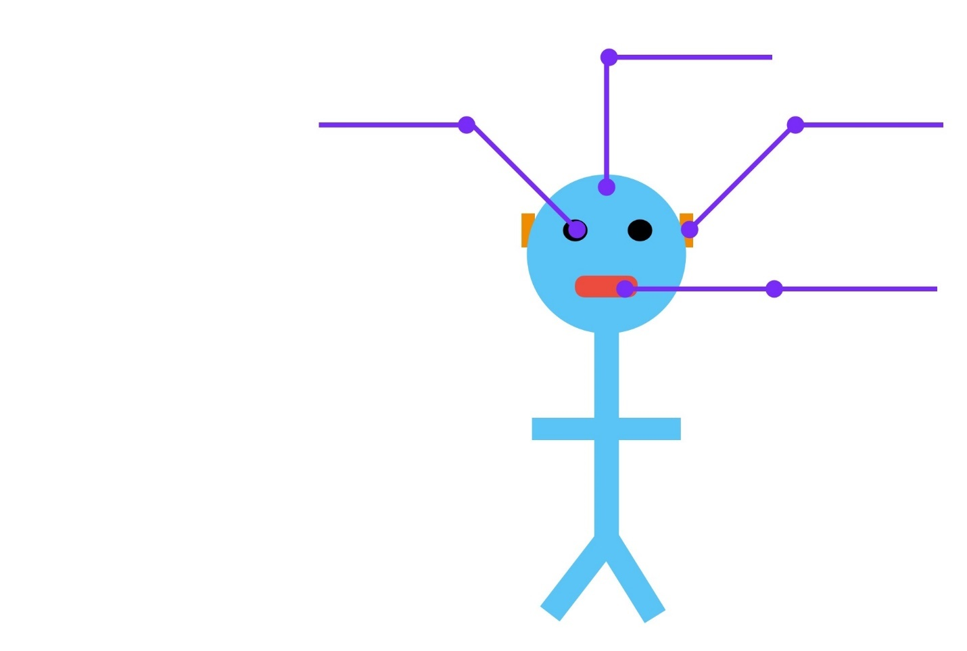







Less of this:



Check Answers

Thought Experiment

Passively listening is like observing a house from the street. While we can admire the beautiful architecture of the house from the outside, we will miss the beauty of the inside of the house. We can’t discover the different rooms of the house.

In conversations, active listening allows us to unlock the doors and walk through the rooms discovering new context and diving deeper into the conversation. (Credit: Hrishikesh Hirway, TED's Talk gives this symbolism).

whatisthisnotworkinghelpwhatisthisnotworkinghelpwhatisthisnotworkinghelp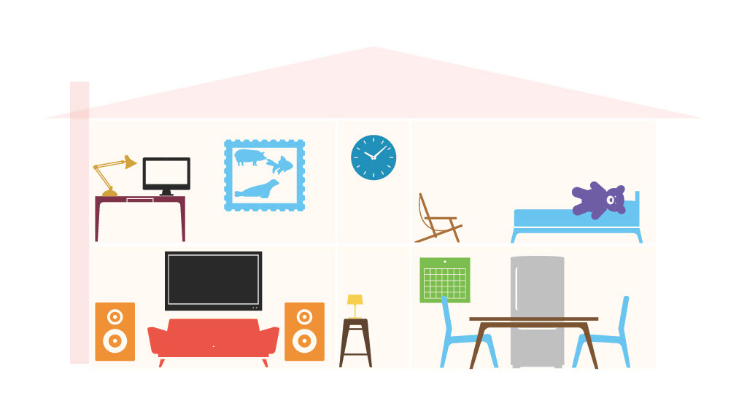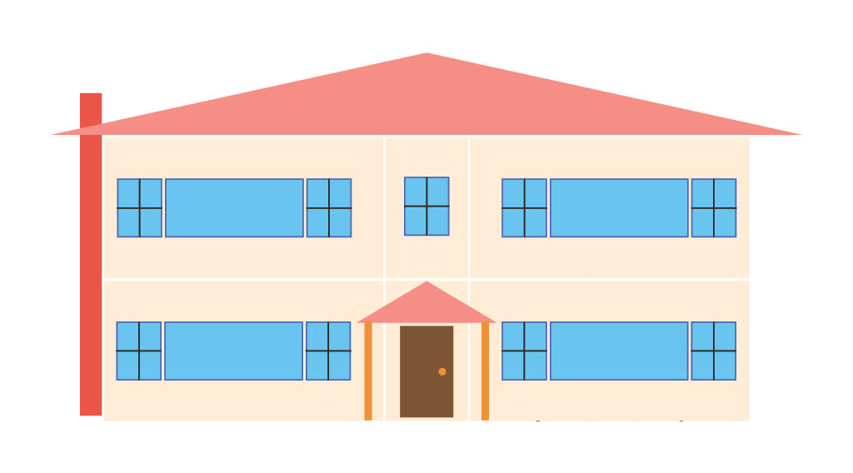

Hover over (or tap) the image, having active learning skiils allows us to learn details we didn't know before.

**Why it Matters**

As People

As humans we want to, we need to be listened to. As Kate Murphy discusses in “You're Not Listening: What You're Missing and Why It Matters”, she describes how not being listened to causes loneliness. Loneliness is described as a public health crisis. Both listening and having someone that listens are important for mental health. For ours and those we love.

As Murphy puts it only through listening, “engage, understand, connect, empathize as human beings” (Murphy 2). No relationship will work without listening - we have two years and one month for a reason.

Moreover, miscommunication has disastrous consequences - fatal consequences. Wars have been fought over for a lack of listening. As an example: disasters like those of United Airlines 173 demonstrate the consequences of not listening.

The airplane had a landing gear issue that the captain, the person responsible for making final decisions, became fixated on. The fixation caused the airplane to run out of fuel. Accident investigators cited that the captain failed to “properly respond to [..] the crewmember’s advisories regarding fuel state” (NTSB 5). Not listening costs lives, that’s why listening matters.

As Tutors

As tutors, our listening skills aren't necessarily “life saving”. Yet - despite this being able to listen to others is still critical to the success of our students. With active listening skills we may be able to help students identify the problem they need help with. Sometimes, there may be other issues like poor studying skills, that are contributing to their struggles. Knowing this can help us as tutors know how we can help our students develop further independence.

Kate Murphy mentions how some conversations that had active listening allowed her interviewees to notice stuff they haven’t before. Our active listening skills can help our students experience the same - and allow themselves to reflect and improve as students, independently.

* **How to?**
* **Be open to new ideas -** When we listen we have to be open minded and be ready to learn something new. If our mind doesn't want to listen we aren’t active listeners. As tutors, we need open-mindedness to help us identify struggles our students have.
* **Stop multitasking -** Physically we need to stop what we’re doing and listen. We need to make eye contact and listen. Within us, within our thoughts, we need to not multitask too. We can not fully appreciate what someone else says while thinking about something else. As tutors, we need to focus on the student when we’re listening to them. We don’t want to be thinking about our own work or other tutees. We also don’t want to be forming judgments as they speak. Our minds need to be fully occupied on what they say.
* **Let the other person know you’re engaged without drawing focus on yourself -** relating from personal experiences aren’t a form of active listening. Physically we can nod to let the other person know we’re engaged. From training level 1, we learned that careful useful use of silence is also a skill. We make space for people and our tutees to think. But at other times, we may have to ask questions to engage and dig deeper. As tutors we can do the same to help our students build their independence by identifying the underlying struggles they have.
* **Listen to non-verbal cues -** We want to listen to non-verbal cues like body language. We can use body language to identify how they feel.
* **Paraphrase and summarize -** repeating what people say can indicate to the person we are listening to really understand what they said.
* **Practice -** listening is a lifelong skill. We need to practice listening in order to be better at it.

**Confirmation**

Let’s take time to reflect on what active listening is. Act as if you are working with a student who had an assignment on active listening. Create questions based on Bloom’s Taxonomy that you could use to determine how well a student understands the terms, themes, and arguments presented. Answer them too. This question will not be graded, it is for your reflection. Please print out this section and upload to Classes. Sample questions have been provided.

|  |  |  |  |
| --- | --- | --- | --- |
| **Level of Bloom’s Taxonomy** | **Sample Questions** | **Your Questions** | **Sample Answers** |
| *Remember* – recalling facts and basic concepts. “Define, duplicate, list, memorize” | 1. What is hearing? 2. What is listening? 3. List ways to listen actively |  |  |
| *Understand* – explain the idea or concepts “describe, explain, select” | 1. Explain why active listening is important 2. Explain why today’s encouragement of “listening to our thoughts” is harmful. 3. Describe the ways active listening can improve our role as tutors. |  |  |
| *Apply* – use information in new situations “solve, interpret, execute” | 1. A friend is struggling with active listening, how can you help them? 2. A professor isn’t a great listener, how should and why should they improve? |  |  |
| *Analyze* – draw connections among ideas “relate, compare, contrast” | 1. Look into what “crew resource management” is, how does it relate to active listening? 2. Contrast an active listener to a good hearer. |  |  |
| *Evaluate* – justify a stand or decision “argue, defend” | 1. Defend why active listening is important for emotional intelligence. 2. Argue why John Gottman's argument against active listening is wrong. 3. Argue why being a bad listener doesn’t necessarily make you a bad person. |  |  |
| *Create* – produce new or original work “design, develop, investigate” | 1. Investigate more into how we as tutors can empower ourselves to become better listeners. |  |  |

**Conclusion**

Listening to others is both important for our role as tutors, and more so, our role as people. Let’s work together to listen carefully, listening with all of our body - for the people we love.

**Citations**

* British Heart Foundation. 10 tips for active listening. https://www.bhf.org.uk/informationsupport/heart-matters-magazine/wellbeing/how-to-talk-about-health-problems/active-listening.
* Center for Effective Learning. How to Use Active Listening Skills to Coach Others. www.ccl.org/articles/leading-effectively-articles/coaching-others-use-active-listening-skills.
* Hirway Hrishikesh. “What you discover when you really listen”. TedTalk, uploaded by TEDMonterey. https://www.ted.com/talks/hrishikesh_hirway_what_you_discover_when_you_really_listen.
* National Transportation Safety Board (1979. June 7). AIRCRAFT ACCIDENT REPORT AAR7907. https://www.ntsb.gov/investigations/AccidentReports/Reports/AAR7907.pdf.
* Murphy Kate. You're Not Listening: What You're Missing and Why It Matters. New York, NY. January 2020.
* Patricia Mulvania, R. (2020, October 21). The importance of active listening. Gift of Life Institute is a division of Gift of Life Transplant Foundation. https://www.giftoflifeinstitute.org/the-importance-of-active-listening/.
* PROFESSIONAL LEARNING BOARD LLC. Be a Listening Teacher. https://k12teacherstaffdevelopment.com/tlb/be-a-listening-teacher/.
* University of the People. Hearing vs Listening – Mastering Communication. https://www.uopeople.edu/blog/hearing-vs-listening/.

Created by Kenji Okura for Learning Commons General Training 2.

Powered by [w3.css](https://www.w3schools.com/w3css/default.asp)